Who can get the vaccine? There are not enough vaccines to go around right now. For that reason, only healthcare workers and people who take care of covid-19 patients, as well as long-term care facility residents and staff are getting vaccinated.
Project HOPE Of Cleveland, Inc.
I want to get a Covid-19 vaccine. What should I know?

We talked to some healthcare workers who have gotten the vaccine, and they wanted to share their experiences with you!
Josh, a pharmacist, said his arm hurt for 2-3 days afterward.
Kim, a nurse: “Very sore arm (worse than flu shot) for 2-3 days. I broke out in a rash that itched badly on my arms and trunk. Used cortisone cream for two days which relieved the itching. I can still see the rash, but it doesn’t itch anymore.”
Pam, a physican’s assistant: first dose six days ago. Mildly sore arm, no swelling, no fever/chills. Less reaction than shingrix. (the shingles vaccine)
Mindy, a nurse practitioner: Agree arm pain is the worst part of it. Similar to a tetanus shot. Felt a little poopy the next 2 days - tired, muscle aches but all very mild and resolved. Not even a blip compared to having influenza A this year as a “young and healthy” individual and nothing compared to what my patients have described having COVID to be like.
Tracy, a doctor: my husband (also a doctor) and I both had a sore arm for a day and extreme fatigue. The bad symptoms after the vaccine are actually a GOOD thing-it means your body is mounting an immune response. COVID is deadly and comes with a lot of long term consequences so the benefit of the vaccine definitely outweighs the risk.
Rose, a nurse: no arm soreness, a very mild scratchy/sore throat with barely present runny nose but I do the same thing after flu vaccine. Only for about a day or so.
Maria, a nurse: only experienced arm discomfort and felt a little tired the next day.

Next will be Ohio residents older than 65, people who have certain health disorders, and people who work in school. This will hopefully happen sometime early this year (2021), although the date is still unknown.
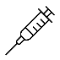
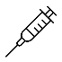
Where will I go to get my vaccine? There will be locations all over the state. There will be a place close to home where you will go, such as a pharmacy or a health center. As of right now there is not more information, but we will let you know when it is 5thavailable.
Will my vaccine be two doses? The vaccines that are available right now need two doses to be effective. You will get a card with your first shot that says where you were vaccinated, and which shot you were given. You will be told when and where to get your second shot, which will happen a few weeks later.
Will I still have to wear a mask and be careful about staying 6 feet apart after I get my shots? Yes. It can take time for your body to build up immunity to the coronavirus after you get vaccinated. The vaccine is meant to keep you from getting sick, but you can still carry the germs on and in your body, and you can give it to other people.
Source: https://states.aarp.org/ohio/covid-19-vaccine-distribution
Vaccine side effects:
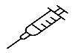
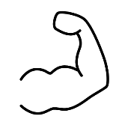
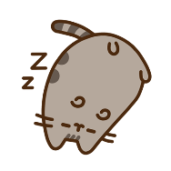
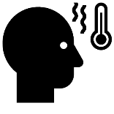
When you get your shot, your body will have an
“immune response” which means that it is learning how to fight the coronavirus without actually being infected. You may not feel any different at all, or it can make you feel unwell for a day or two after getting the shot. Your arm may feel sore or be red from the injection, and you might have a fever, chills, headaches, tiredness, and joint or muscle pain. Every body is different, and will have its own experience after the shot.
OUCH!
Source: coronavirus.ohio.gov

